**Temperature, resources, and predation interact to shape phytoplankton size-abundance relationships at a continental scale**

[Running title]

**Abstract**

**Aim:** Communities contain more individuals of small species and fewer individuals of large species. The relationship of mean abundance with mean body size usually has a relatively steep negative slope. According to the ‘metabolic theory of ecology’ (MTE), this relationship should exhibit a loglinear slope of -3/4 that is typically invariant across environmental conditions, based on an assumed universal, but now challenged 3/4-power law for the body-mass scaling of metabolic rate. Here, we investigate how environmental factors may interact to affect the relationship between body size and abundance altering the slope of -3/4.

**Location:** USA

**Time period:** 2012

**Major taxa studied:** Phytoplankton

**Result:** We find that the CCSR slope is significantly lower than -3/4 and near -1 overall (perhaps due to isometric metabolic scaling that has been observed in other studies) and varies substantially between -0.33 and -0.93 across gradients of temperature, nutrient (phosphorus) supply and zooplankton predation pressure across 1048 freshwater lake phytoplankton communities in the USA. Specific values of the CCSR slope depend on complex interactive effects between the above environmental factors. Phytoplankton communities have orders of magnitude more small or large cells depending on environmental conditions than would be predicted by the MTE.

**Conclusion:** Although based on observational data, our results suggest that continued climate warming and nutrient enrichment into the future will significantly alter size-abundance relationships of freshwater phytoplankton communities via shifts in metabolic scaling or other poorly understood processes, but in different ways depending on interactions between temperature, nutrient supply and zooplankton predation.

**Keywords:** body size, phytoplankton, predation, resources, size-abundance relationship, temperature.

**Introduction**

Climate warming and excessive resource supply are major drivers of global environmental change in freshwater ecosystems (Woodward, Perkins, & Brown, 2010). Changes in temperature and resource supply can modify physiological processes at the individual level which, in turn, can affect ecological phenomena at higher levels of biological organization, such as communities and ecosystems (White, Ernest, Kerkhoff, & Enquist, 2007; Perkins et al., 2019). Although the independent effects of temperature and resource supply on many kinds of biological processes are relatively well studied, much less is known about how these factors interact with each other and body size to affect various physiological and ecological processes, especially at the level of ecological communities (Cross, Hood, Benstead, Huryn, & Nelson, 2015).

Many physiological and ecological processes are strongly associated with organismal body mass (Brown, Gillooly, Allen, Savage, & West, 2004; Woodward et al., 2005; White et al., 2007). For example, population abundance (N) is negatively related to body mass (M), often approximating the power function N ∝ M-3/4 (Damuth, 1981, 1991, 1998). This is commonly explained as being the result of M relating to metabolic rate (R) as R ∝ M3/4, and thus the total energy (E) used by each species should scale independently of body mass (E ∝ N × R ∝ M3/4 × M-3/4 ∝ M0), as specified by the Energetic Equivalence Rule (EER) (Nee, Read, Greenwood, & Harvey, 1991; Damuth, 1981). Furthermore, the total abundance of organisms (N) in an ecological community relates negatively to the average M of species in that community, either through time or across space. Such size-abundance relationships across communities (i.e., cross-community scaling relationships, CCSR as defined by White et al., 2007) have received increasing attention in recent years and have been used to test EER predictions (Enquist, Brown, & West, 1998; White, Ernest, & Thibault, 2004; Meehan, 2006; Li, 2002; Long & Morin, 2005; Moran, Lopez-Urrutia, Calvo-Diaz, & Li, 2010; Arim et al., 2011; Gjoni, Cozzoli, Rosati, & Basset, 2017; Gjoni & Basset, 2018; Gjoni & Glazier, 2020).

Although the -3/4 scaling exponent of size-abundance relationships has been claimed to be universal, considerable deviations have been reported for plankton communities (Cavender-Bares, Rinaldo, & Chisholm, 2001; Huete-Ortega, Cermeno, Calvo-Diaz, & Maranon, 2012; Marañón, 2015). Thus far, this variation has largely been assumed to be idiosyncratic, with little investigation of whether it is *systematically* related to specific environmental factors or ecological processes. The existence of any such systematic variation would undermine the claim that the relationships between body size, energetic requirements and population abundance described above are universal. This universality is assumed by the influential metabolic theory of ecology (MTE), which attempts to explain a wide range of ecological phenomena based on underlying physiological processes (Brown, Gillooly, Allen, Savage & West, 2004; West & Brown, 2005). Therefore, investigating variation in size-abundance relationships may help scientists to identify weaknesses in existing theoretical models such as the MTE, as well as possible additional mechanisms that should be incorporated into them. In addition, recent studies have reported significant deviations in metabolic scaling exponents from those predicted by the MTE. In particular, the metabolic scaling slope of planktonic communities has been found to be ~1 (Huete-Ortega et al., 2012; Marañón, 2015) instead of ¾, implying that the slope of the size-abundance relationship should be -1. Variation in metabolic scaling has been widely observed and points towards the need for a careful examination of the assumptions and predictions of the MTE, and a consideration of alternative models (e.g., Glazier 2014a, 2018, 2022; Harrison, 2017; White et al., 2019; Kozłowski, Konarzewski, & Czarnoleski, 2020).

Temperature affects the rates of physiological and ecological processes (Cossins & Bowler, 1987; Brown, Gillooly, Allen, Savage & West, 2004, Dell, Pawar, & Savage, 2011). The MTE assumes that the rates of biochemical reactions comprising metabolism increase exponentially with increasing temperature, independently of body size (Gillooly, Brown, West, Savage, & Charnov, 2001; Brown, Gillooly, Allen, Savage & West, 2004). This implies that the CCSR slope should also not change across environmental temperature gradients (Fig. 1A). Nevertheless, a few studies have shown that temperature can cause the CCSR slope of planktonic communities deviate from the expected -3/4 slope and also the -1 slope generally seen in natural planktonic communities (Moran et al., 2010; Gjoni & Glazier, 2020). Increasing temperature appears to increase the proportion of small organisms, thereby decreasing the slope of the size-abundance relationship (Li, Harrison, & Head, 2006; Moran et al., 2010; Gjoni & Glazer, 2020; Pomeranz, Junker, & Wesner, 2022). At least two hypotheses can explain how temperature affects size-abundance relationships. First, temperature may affect the body-mass scaling of metabolic rate at the individual level (Glazier 2005, 2014b, 2020; Killen, Atkinson, & Glazier, 2010; Rubalcaba, Verberk, Hendriks, Saris, & Woods, 2020). Second, temperature may directly affect body size at the individual and community levels (as described by ‘temperature-size rules’ – TSRs) (Daufresne, Lengfellner, & Sommer, 2009; Atkinson, 1995; Verberk, Atkinson, Hoefnagel, Hirst, Horne, & Siepel, 2021), scaling up to affect the size-abundance relationship (Fig. 1B). In short, the mechanistic connections between temperature, metabolism and body size at the individual and community levels may be more complex than assumed by the MTE, causing size-abundance relationships to vary, rather than conform to a single universal slope.

Resource supply may also have a key role in determining the slope of size-abundance relationships. The EER predicts that resources are equally partitioned between species in a community regardless of their body size, thus causing no change in the scaling slope. Furthermore, increased resource availability increases the energy available for, not only maintenance metabolism, but also growth and reproduction, thereby increasing population abundance (Abrams, 1993; Meehan, 200). This is because if an increase in growth and reproduction occurs independently of body size, then greater resource availability may increase the intercept of size-metabolism and size-abundance relationships without changing their slopes (~3/4, Fig. 1C). However, according to the ‘resource rule’ (RR), changes in resource availability cause changes in body maintenance, growth and reproduction that modify the body size of species (McNab, 2010; Huston & Wolverton, 2011), thus possibly changing the size-abundance relationship. This is consistent with observations of planktonic communities, where increasing nutrients increase the abundance of larger organisms relative to expectations based on -¾ or -1 scaling, whereas decreasing nutrients increase the relative abundance of small organisms (Irwin, Finkel, Schofield, & Falkowski, 2006). This may be because large species are able to allocate more energy to growth under high-resource supply conditions because of their higher resource uptake rates, but are extirpated under resource-limited conditions. Small species require fewer resources, and therefore do relatively better when resources are limited (Litchman & Klausmeier, 2008; Qu et al. 2019; Yang et al., 2021). Low resource-supply levels should therefore decrease the size-abundance relationship slope, whereas high levels of resource supply should increase the slope (Fig. 1D).

Predation may also cause changes in the relationship between the abundance and body size of prey organisms. The MTE predicts that the slopes of size-abundance relationships should not change among trophic levels (e.g., phytoplankton to zooplankton to planktivorous fish) whereas overall abundance should be higher at lower trophic levels. However, two hypotheses show how predation may affect the size-abundance relationships of their prey. First, size-selective predation may interact with body size to affect the metabolism of prey (Glazier et al., 2011), which may, in turn, change the slope of a size-abundance relationship. Second, size-selective predation may directly affect the abundance of prey with different body sizes, which is true for planktonic organisms, where the zooplankton grazing (i.e., herbivore zooplankton that feed on phytoplankton) controls phytoplankton (i.e., prey) body sizes (Sommer, Peter, Genitsaris, & Moustaka-Gouni, 2017). Size-selective predation may cause a higher proportion of large or small organism, that may, in turn cause a shallower or steeper CCSR slope with increasing predation pressure (Fig. 1F and G).

Furthermore, temperature and resources may interact to shape the size-abundance distribution, though presently we do not have clear expectations of how this should occur (see e.g., Sommer et al., 2017; O’Gorman et al., 2017). There is extensive evidence from a wide variety of organisms that temperature and resource availability interact to shape organismal body size (Agawin, Duarte & Agusti; 2000), growth rates (Brett, 1971; Thomas et al., 2017; Huey & Kingsolver, 2019) and feeding rates (Rall et al., 2012). The body sizes and metabolic rates of prey organisms may also be affected by predators (Glazier et al., 2011; Steiner & Van Buskirk, 2019; Glazier et al., 2020) in temperature-dependent ways (Gjoni & Glazier, 2020; Glazier et al., 2020). On one hand, at the community and ecosystem levels, increasing temperature may affect food web structure by favoring primary producers over predators and herbivores, leading to reorganization of the nutrient supply in the ecological community (Petchey & Belgrano, 2010). On the other hand, increasing temperature may also increase the relative number of predators, provided that bottom-up nutrient supply is also increased (O’Gorman et al., 2019). Clearly these structural responses to warming and nutrient availability may alter food web structure (O’Connor, Piehler, Leech, Anton, & Bruno, 2009), community composition (Roselli & Basset, 2015; Ryan, Thomas, & Litchman, 2017), and trophic interactions (Dell, Pawar, & Savage, 2014; Bideault, Loreau, & Gravel, 2019). Any one of these processes at the individual or community level could plausibly lead to temperature-resource-predation interactions shaping size-abundance relationships at the community level. The mechanisms underlying those interactions remain obscure, and future modelling work would be valuable in exploring these.

We investigated how temperature, resource availability and predation pressure affect the size-abundance relationships of phytoplankton communities across 1048 lakes in the USA. Our study takes advantage of continental-scale observational data on community properties to evaluate whether the specific quantitative predictions of the EER and MTE vary across natural gradients in ways those theories do not account for. Therefore, we expand our understanding of how environmental drivers interact to influence community and ecosystem level processes. Phytoplankton communities, in particular, are highly responsive to environmental change (Van de Waal & Litchman, 2020) and are also especially useful for undertaking CCSR studies because they exhibit a broad range of cell sizes (Finkel et al., 2010) and vary strongly in composition (both species and size) and density across environmental gradients. Therefore, our study can improve our understanding on how community structure changes in response to climate warming and nutrient enrichment, the two key drivers of ecosystem change in lakes and oceans (e.g., Moss, 2012).

**Material and methods**

We used observational data from 1048 US lakes to model the effects of temperature, nutrients, and zooplankton on the size-abundance relationship across communities (i.e. the cross-community scaling relationship, CCSR, as defined by White et al., 2007).

*NLA dataset*

We used data from continental US lakes collected as part of the 2012 National Lakes Assessment survey conducted by the US Environmental Protection Agency (Fig. 2). NLA is a synoptic sampling program of lakes, reservoirs, and ponds implemented across the continental US (Pollard, Hampton, & Leech, 2018). The lakes were sampled once in the summer (June–September) and were selected from the National Hydrography Database. At each lake, an extensive set of environmental variables was measured, but we provide sampling details only for variables used in our analysis. Field crews used standardized sampling methods across all sites, with collections made during the morning to early afternoon. All data are freely available online (<https://www.epa.gov/national-aquatic-resource-surveys/manuals-used-national-aquatic-resource-surveys>).

*Variables examined in this study*

To examine the size-abundance relationship (CCSR) slopes across lake phytoplankton communities of the NLA dataset, we used the following variables (biological, chemical, and physical measurements and samples were taken at a deep, open water location (i.e., <50 m) in each lake ecosystem):

* Cell volume: for each sample (corresponding to a different lake) all cell biovolumes of all identified taxa were quantified (μm3 mL-1). Formulae for solid geometric shapes that most closely match the cell shape were used to estimate biovolume (Hillebrand et al., 1999). Cell biovolumes of each taxon were then divided by the population density (cells mL−1) to estimate the cell volume (S).
* Population density: phytoplankton population size per unit area (cells mL−1) of all taxa was summed to estimate total population density in each lake (D).
* Temperature: multi-parameter water quality meters (or sonde) were used to measure temperature (T - °C) at the open water location (i.e., <4 m) in each lake ecosystems (for each sample there was one temperature measurement taken).
* Total phosphorous: water samples were then filtered (0.4μm) and total phosphorous (P – μg L-1) of each sample from each lake was measured with adding ultra-pure acid (e.g., H2SO4)at each water sample.
* Herbivorous zooplankton: mean biomass of herbivorous zooplankton (μg L-1) in each lake was used as a proxy for zooplankton predation pressure (Z) on phytoplankton. To identify the functional groups (e.g., herbivore, predator, and omnivore), each zooplankton species was XXXodellin by the expert who identified the species.

The NLA sampling of both biotic and abiotic components and sample processing procedures are described in detail and discussed elsewhere (<https://www.epa.gov/national-aquatic-resource-surveys/manuals-used-national-aquatic-resource-surveys>).

*Data exclusion rules*

We excluded some data to avoid bias in our size-abundance relationships. After these exclusion steps, we were left with data from 1048 lakes. The exclusion rules are reported below:

1. A small number of lakes were visited and measured more than once. To avoid complications associated with non-independence of data points, we included data from only the first visit to each lake.
2. For three lakes, *in situ* temperatures of >60 °C were recorded. We treated these as errors and excluded these temperature values. For reference, the next highest temperature recorded was 35.5 °C.
3. We also excluded zooplankton species that were recorded as being parasitic or carnivorous from our analyses, with the goal of capturing the herbivorous zooplankton. Not all species had an ecological descriptor, so this step only excluded species for which information was available in the dataset.
4. Data from 85 lakes were excluded from the model fitting process because of the absence of measurements of at least one of our study variables.

*Data processing steps*

For each lake, we calculated the following quantities:

* total population density of phytoplankton cells in each lake
* mean volume of all cells in each lake
* mean zooplankton biomass in each lake

*Hypotheses evaluated*

We quantified the CCSR and its dependence on environmental variation using linear mixed models. As a first step, we developed *a priori* hypotheses about how environmental variation should affect the CCSR.First, we tested whether the slope for the phytoplankton CCSR for all lakes sampled was -3/4, as predicted by the MTE, or to -1 as observed in previous studies. Second, we tested whether the CCSR scaling slope was invariant, regardless of variation in water temperature, total phosphorous availability and zooplankton biomass (as a proxy of predation pressure), again as predicted by the MTE (Fig. 1). These environmental variables were selected because they are all known to affect physiological and ecological processes that are related to the body size and the abundance of the species present in the community (*see* Introduction).

*Model structure*

We translated these hypotheses into the following linear mixed model:

$$log A \sim Normal(μ, σ)$$

$$μ=α+ βX+ δ_{site}$$

where log abundance (A) (or rather log cell density) is normally distributed with an unknown mean $μ$ and standard deviation $σ$, and $μ$ is defined by a linear model with an intercept *α*, a random effect $δ_{site}$ and 10 fixed predictors represented by $βX$. These contain all main effects (mean cell size, temperature, nitrate concentration, and zooplankton biomass) along with a few selected two, three, and four-way interactions for which we had *a priori* expectations.

Predictor and response data represent single measurements in each lake. We calculated means per lake when multiple measurements were taken during one sampling effort (no vertical structure in these variables was recorded and so this averaging does not bias measurements). All variables were log10-transformed before model fitting. After transformation, predictor variables (including temperature) were centered to improve model fitting and interpretation.

*Statistical Analysis*

Models were assessed using Bayesian inference. Specifically, we generated joint posterior distributions for each model with the No-U-Turn sampler (NUTS) using *rstan* (Stan Development Team 2022) via the *brms* (Buerkner 2015) package in R (R Core Team, 2022). Priors were determined based on prior information and prior predictive modeling following Wesner & Pomeranz (2021) (Figure S1). We ran four independent chains for 2000 iterations for each model, with the first 1000 iterations discarded as warm-up. We checked model convergence using trace plots and by ensuring that r-hat was <1.1 (Gelman & Rubin 1992). All models achieved convergence. We estimated the mean and 95% credible intervals (CrI) for each model parameter and for each derived quantity, from the joint posterior distribution of each model. Finally, we assessed model fit using posterior predictive checking (Figure S2).

*Justification of modelling choices and exploration of alternatives*

We made choices about the interactions to include in the model, the proxy of the resource availability and other issues about the model, see below:

* This model does not include all possible interactions. We intentionally excluded one possible 2-way interaction (*P x R*), three possible 3-way interactions (*P x R x T, P x R x T, P x R x S*) and the 4-way interaction (*S x T x R x P*). We restricted the terms in our model based on the hypotheses described earlier, in part to meaningfully evaluate them with a relatively small dataset of ~1000 points. All results presented are based on this restricted model.
* We used total phosphorous as a proxy for resource availability, this is because phosphorus is more commonly the growth-limiting nutrient in lake ecosystems (Pomati, Shurin, Andersen, Tellenbach, & Barton, 2020).
* There is some uncertainty associated with estimates of the mean phytoplankton volume in each lake. We have ignored this uncertainty in the models presented, but we subsequently explored weighting points by 1/SE of the mean volume estimate. This weighting did not alter any conclusions and so we present the simpler models here.
* Because some phytoplankton species are colonial, our quantification of abundance and volume at the cell level arguably misses important aspects of phytoplankton ecology. We therefore also analyzed our data at the colony level and found similar patterns (Appendix S1: Fig. S1).

**Results**

The slope of the size-abundance relationship for all phytoplankton communities in our dataset was substantially lower than the MTE expected value of -0.75. The slope averaged -0.97 (95% CrI: -1.03 to -0.91), with a greater than 99% probability of being lower than -0.75 (Fig. 3, Table 1).

The inclusion of environmental predictors in the model revealed strong (and likely causal) relationships that altered the observed CCSR slope of -0.97 that is presented in Fig. 3. In particular, temperature (*T*), total phosphorous (a proxy for resource availability, *R*) and zooplankton biomass (a proxy for predation pressure, *P*) interacted strongly to alter the slope (Table 1). At low *R* and *P*, *T* had relatively little effect on the abundance of both small and large phytoplankton, thus resulting in no strong changes in the slope or intercept (Fig. 4A; -0.54, -0.56, -0.58, respectively). However, at high *R* and low *P*, the abundance of small phytoplankton increased relative to that of large phytoplankton with increasing *T* (Fig. 4B; -0.35, -0.75, -0.83, respectively). The same was observed at low *R* and high *P,* thus making the slope more negative(Fig. 4C; -0.33, -0.73, -0.93, respectively). However, at high *R* and *P*, *T* again had relatively little effect on the abundance of both small and large phytoplankton (Fig. 4D; -0.90, -0.91, -0.93, respectively)*.* Viewing the same relationship from a nutrient-supply perspective, at low *T* and *P*, increasing *R* increased the abundance of large phytoplankton more than that of small phytoplankton, thus making the slope less negative (Fig. 5A; -0.73, -0.55, -0.35, respectively). However, at high *T* andlow *P,* there was a small increase in abundance with increasing *R* that was similar across all size classes (Fig. 5B; -0.90, -0.90, -0.90, respectively). The same was observed at high *T* and *P*, thus resulting in no strong changes in the slope (Fig. 5D; -0.93, -0.90, -0.86, respectively). However, at low *T* and high *P*, the abundance of small phytoplankton increased relative to that of large phytoplankton with increasing *R* (Fig. 5C; -0.33, -0.65, -0.93, respectively).Viewing the same relationship from a predation-pressure prospective, at low *T* and high *R*, the abundance of small phytoplankton increased relative to that of large phytoplankton with increasing *P,* thus making the slope more negative (Fig. 6C; -0.54, -0.78, -0.90, respectively). However, under the other conditions, *P* had relatively little effect on the abundance of both small and large phytoplankton (with a relatively stable slope~-0.50 under low *T* and *R*, and ~-0.80 under the other environmental conditions), thus resulting in no strong changes in the slope or intercept with increasing P (Fig. 6A, B and D).

The values of the slope above are ‘slices’ of the continuous effects of *T*, *R* and *P* on the CCSR slope. The CCSR slope, in general, increases continuously and becomes less negative (i.e., with a value higher than ~-0.75 and close to ~-0.25, yellow color) with decreasing *T* and *P* and increasing *R* (Fig. 7). By contrast, the CCSR slope decreases continuously and becomes steeper (i.e., with a value lower than of ~-0.75 and close to ~-1, blue color) with increasing *T* and *P* and decreasing *R* (Fig. 7).

**Discussion**

Our findings indicate that multiple abiotic and biotic environmental factors affect community level size-abundance relationships (specifically, the CCSR) in ways not predicted by the metabolic theory of ecology (MTE). They suggest that CCSRs may not follow classic three quarter power scaling because of taxonomically and environmentally related variation in metabolic scaling (as documented in many other studies: see review of Glazier, 2022) and/or direct effects on body-size distributions acting via shifts in size-related mortality, growth or other biological processes.

Our findings are inconsistent with MTE predictions in two ways. First, the slope for the size-abundance relationship that we observed was not -3/4, as predicted by the MTE (Brown, Gillooly, Allen, Savage & West, 2004), but -0.97 (Fig. 2). This isometric size-abundance relationship has also been reported for phytoplankton assemblages by Cavender-Bares et al. (2001), Huete-Ortega et al. (2012), and Marañón (2015). However, the negatively isometric size-abundance relationship that we found is still consistent with the EER relating metabolism to size-abundance relationships. For reasons that are not well-understood, the metabolic scaling slope has been found to be ~1 for phytoplankton (Huete-Ortega et al., 2012, Marañón, 2015) instead of ¾, implying that the slope of the size-abundance relationship should be -1, as we observed (Fig. 2). Proportional (1:1) relationships of cell size with metabolic rate and abundance result in equal energy expenditure for all cell size classes, as predicted by the EER. Therefore, although we did not find the canonical -3/4 scaling of the MTE, the -1 slope that we did find is consistent with the EER. Second, although the MTE predicts an invariant size-abundance relationship regardless of taxon and environment, we found that temperature, resource supply and predation interact to cause variation in the CCSR slope of lake phytoplankton communities. These results suggest possible weaknesses in the present MTE framework and point towards the importance of environmental effects on either metabolism, body size, or the physiological and ecological processes connecting metabolism with size-abundance relationships.

Our findings show that temperature, resources and zooplankton predation interact to affect the slope of phytoplankton size-abundance relationships in lake ecosystems. These effects are inconsistent with a simple link between metabolism and size-abundance relationships. To summarize our findings: under low predation risk (Fig. 4A and B), small organisms are favored (more abundant than expected based on -3/4 scaling) when temperature and nutrient supply are both high, whereas large organisms are favored (more abundant than expected; Fig. 4A and B) only when temperature is low and nutrient supply is high. However, under high predation risk (Fig. 4C and D), small organisms are favored when temperature is high and nutrient supply is low, whereas large organisms are favored only when temperature and nutrient supply are both low. Under either low predation pressure and low resource conditions, or high predation pressure and high resource conditions, temperature has negligible effect on the size-abundance slope (Fig. 4A, D).

The benefits of small size under low resource conditions are well understood in phytoplankton: small cells are more effective at assimilating resources (light and nutrients) and require fewer resources per cell, thus giving them a competitive advantage over larger cells under low resource conditions (i.e., R* rule; Tilman, 1982). However, why small individuals are favored under high temperature and resource conditions (at low predation pressure) is less clear. Small phytoplankton cells are commonly observed to be more abundant at high temperatures, but this observation is usually attributed to low nutrient conditions, because of the earlier nutrient-use effectiveness argument and because temperature and nutrients covary negatively in lakes (Vucic-Pestic et al., 2020). This does not explain our results here, because our model results imply that small individuals are more abundant even when high temperatures and high nutrient concentrations co-occur. This apparent conundrum can be resolved if the competitive advantage of small individuals increases with temperature, independently of resource concentration. This appears to be the case in phytoplankton: the relative competitive advantage of small cells for nutrient uptake and usage increases with increasing temperature. Prior theoretical work based on empirical measurements of phytoplankton physiology supports this claim (Reumann, Holt, & Yvon-Durocher, 2014). This is because the competitive advantage of small cells at high temperatures may be best expressed at high nutrient levels that allow them to manifest high rates of nutrient uptake, growth and reproduction. If true, this would explain why large individuals are advantaged (relatively) only in cold, resource-rich conditions (Fig. 6C).

Two explanations for the patterns in our dataset that we can rule out are the intraspecific patterns of the temperature-size rule (TSR) and the resource rule (RR), as strictly defined (Daufresne et al., 2009; McNab, 2010). The TSR is a plastic response of individuals to being grown at colder temperatures. The RR states that individuals tend to be larger in areas with high resource availability (McNab, 2010). These do not apply to our study because our estimates include no intraspecific variation. Individual body sizes were not measured separately for each lake; instead, a single mean size estimate for each species was applied. Because there is no intraspecific variation in our estimates, intraspecific variation cannot explain directly any of the patterns that we observed.

Accordingly, our results regarding temperature, resource supply and predation effects on the size-abundance relationship of phytoplankton communities provide partial support for community-level temperature-size and resource rules (TSR and RR) under limited predation pressure, but no support for these rules under high predation pressure. In short, size-selective predation of zooplankton on phytoplankton can significantly alter temperature and resource effects on community-level size-abundance relationships. Specifically, as expected by a community-level TSR, at low predation pressure increasing temperature causes an increase in the relative abundance of small phytoplankton cells and therefore a decrease in the size-abundance relationship slope, but only at high nutrient levels. However, at high predation pressure, increasing temperature causes an increase in relative abundance of small cells only at low nutrient levels. As expected by a community-level RR, increasing resource (nutrient) supply causes an increase in the relative abundance of large phytoplankton cells and therefore an increase in the size-abundance relationship slope, but only at low temperatures and predation pressure. However, contrary to the RR, increasing resources increase the relative abundance of small species when predation risk is high, and temperature is low. Also, contrary to the RR, resource availability has negligible effect on the size-abundance relationship slope at high temperatures. Furthermore, contrary to the TSR, temperature has a minimal effect on the size-abundance relationship slope when resources and predation risk are both low or/and high.

However, the TSR and RR can be applied to community-level patterns as well, despite the fact that the ecophysiological mechanisms underpinning the interspecific patterns may be considerably different and more complex than the physiological mechanisms governing the intraspecific patterns. Setting aside these caveats about mechanisms for the moment, we see in our data that there is an increase in the relative abundance of small species at high temperatures (under some environmental conditions), which is consistent with the ‘species shift hypothesis’ of Daufresne et al. (2009). There is growing evidence for this hypothesis where warming favors an increase in the proportion of small species at community level (Li, 2002; Li et al., 2006; Daufresne et al., 2009; Saito, Perkins, & Kratina, 2021; Pomeranz et al., 2022; Zohary, Flaim, & Sommer, 2021; Morán et al., 2010; Gjoni & Glazier, 2020), which could be considered a community-level TSR (Perkins, 2021). If the RR is extrapolated to the interspecific level, it would also be consistent with some of our findings: under some environmental conditions, the relative abundance of large species increases (causing a less negative CCSR slope) as resource availability increases. Size-abundance relationships in planktonic communities often show this pattern (Gaedke, Seifried, & Adrian, 2004; Morán et al., 2010; Barton, Finkel, Ward, Johns, & Follows, 2013; Irwin et al., 2015; Marañón, 2015; Guiet, Poggiale, & Maury, 2016; Sprules & Barth, 2016). Usually, a more negative CCSR slope (small organisms acquire more resources) is associated with a limited resource supply, whereas a less negative CCSR slope (large organisms acquire more resources) is associated with high resource availability. However, despite this supporting evidence, the lack of precise, agreed-upon mechanisms for the TSR and RR at various hierarchical scales means that presently we cannot clearly and conclusively link them mechanistically from the individual to community levels.

Moreover, size-based community structure of lake phytoplankton appears to depend on zooplankton predation pressure. Size-selective predation by zooplankton can affect phytoplankton CCSRs and their relation to temperature and resource availability. Our findings showed that, under high predation, increasing temperature negatively affected the size-abundance relationship slope only at low nutrient availability and increasing nutrients negatively affect the slope only at low temperatures. Whereas decreasing temperature and resource supply positively affected the slope (Fig. 7A). This implies that when predation pressure is high, increasing temperature under low resources, as well as increasing resource availability under cooler temperature favor small vs. large individuals. Zooplankton may directly alter phytoplankton cell-size distributions by preferentially preying on relatively large phytoplankton cells (Wollrab & Diehl, 2015; Sommer et al., 2017). Indeed, under low predation, low temperature and high nutrients favor larger vs. small individuals whereas, under high predation, low temperature and high nutrients favor the small one (see Fig. 6C) The effect of size-selective predation on phytoplankton CCSRs seems to directly influence the proportion of large versus small individuals in a community. Whether interactions between predation and temperature affect the metabolic scaling of prey organisms (Glazier et al., 2011, Glazier, Borelli, & Hoffman, 2020a,; Glazier, Gring, Holsopple, & Gjoni, 2020b) can alter size-abundance relationships is unknown. Another possibility is that size-selective predation may favor small individuals at low temperature and high resource levels. Phytoplankton species may accelerate physiological rates of metabolism, growth, and reproduction to reproduce faster (i.e., before being eaten) where predation pressure is high, and smaller species may be better able to accomplish this. They may therefore reproduce at smaller body sizes than when zooplankton predation pressure is lower, although this cannot explain the patterns we see in our study due to the lack of data on intraspecific variation. Finally, another response of the phytoplankton to predation pressure is the colony formation by cell adhesion that can be induced by zooplankton grazing (Xiao, Li, & Reynolds, 2018). Again, due to the lack of data on intraspecific variation, we cannot evaluate whether this this colony formation mediates the effect of zooplankton grazing on the size-abundance relationship of the phytoplankton species (Figure S1).

Interestingly, Pomati et al. (2020) have also observed interactive effects of temperature, resource levels and zooplankton predation on phytoplankton CCSR slopes, as we have. However, they found that under high predation, increasing temperature and decreasing nutrients favored large vs. small phytoplankton individuals in a single lake ecosystem sampled at different times. Why these anomalous patterns occurred is not known, but perhaps they are somehow related to size-selective predation by zooplankton, which interacted with the effects of temperature and resource supply. Our results relative to those of Pomati et al. (2020) show that much remains to be learned about how and why temperature, nutrient supply and predation pressure affect size-abundance relationships.

In any case, our results contradict the MTE prediction that size-abundance relationships should be invariant across environmental conditions. Contrary to the MTE and inferences from it, the phytoplankton CCSR slope varied across environmental conditions. Therefore, the assumption that there are simple, environment-independent rules linking body size, energetic requirements and population abundance is likely incorrect. According to the MTE, increasing temperature should increase the metabolic rate and thus resource demand of phytoplankton cells, thus decreasing their abundance at a given resource level. The opposite pattern that we observed may be the result of increased temperature causing increased population growth rates made possible by increased rates of protein synthesis, as found in phytoplankton communities by Toseland et al. (2013). Temperature may also affect the mortality rates of phytoplankton cells (Baker & Geider, 2021), and, in turn, population growth rates and possibly size-abundance relationships, a hypothesis requiring testing. In addition, although various hypotheses, including the metabolic-level boundaries hypothesis (Glazier, 2010, 2014b; Killen et al., 2010), the thermal acclimation hypothesis (Fossen, Pelabon, & Einum, 2019) and the size-dependent oxygen-uptake hypothesis (Rubalcaba et al., 2020; Verberk, Atkinson, Hoefnagel, Hirst, Horne, & Siepel, 2021). All predict that the slope for the rate of maintenance metabolism should decrease with increasing temperature, temperature effects on the size-abundance patterns that we observed across phytoplankton communities apparently cannot be explained simply in terms of these hypothetical physiological effects.

Although some aspects of our results still require further explanation, they demonstrate that predictions from major ecological rules or theories are contingent on environmental conditions. Phytoplankton size-abundance relationships may in general not follow the MTE, unlike that observed for other taxa (Huete-Ortega et al., 2012, Marañón, 2015). Resource availability may change the expression of a community-level TSR (Tabi et al., 2020) and temperature may change the expression of a community-level RR. Furthermore, size-selective predation may change the expression of both community-level ‘rules’.

Our research provides important insights into the response of phytoplankton communities to climate change and forecast changes to size-based community structure, we will need to account for the effects of resource/nutrient availability and predation pressure, rather than only temperature. Understanding how and why size-abundance relationships respond to environmental changes may provide fundamental insights into the ecological malleability of communities in nature (Petchey & Belgrano, 2010). As our inferences here rely on observational data, future experimental work may build on this to link individual-level physiology, growth and survivorship with the structure and processes of populations, communities, and ecosystems, thus linking bodies of ecological theory. Our research also shows that the effects of global change on ecological systems should be examined in realistic ecological contexts and at various hierarchical scales.

**Acknowledgements**

We thank Ethan White for his insightful discussions that helped improve this paper. We also thank Uriah Daugaard for helping to make the map of this study.

**Data availability statement**

Code and data are available at <https://github.com/jswesner/NLAlakes> (to be permanently archived upon submission).

**Conflict of interest statement**

The authors declare no conflict of interest.

**Funding statement**

Vojsava Gjoni was supported by Swiss National Scientific Foundation (SNSF) Scientific exchange grand scholarship provided by the Swiss National Foundation in Switzerland. This material is based upon work supported by the National Science Foundation under Grant No. 2106067 to JSW.

**Biosketch**

**References**

Abrams, P. A. (1993). Effect of increased productivity on the abundances of trophic levels. *The American Naturalist*, 141, 351–371.

Agawin, N. S. R., Duarte, C. M., & Agustí, S. (2000). Nutrient and temperature control of the contribution of picoplankton to phytoplankton biomass and production. *Limnology and oceanography*, 45, 591–600.

Arim, M., Berazategui, M., Barreneche, J. M., Ziegler, L., Zarucki M., & Abades, S. R. (2011). Determinants of density–body size scaling within food webs and tools for their detection. *Advances in Ecological Research,* 45, 1–39.

Atkinson, D. (1995). Effects of temperature on the size of aquatic ectotherms: exceptions to the general rule. *Journal of Thermal Biology,* 20(1−2), 61–74.

Atkinson, D., S. A. Morley, and R. N., and Hughes. (2006). From cells to colonies: at what levels of body organization does the ‘temperature‐size rule’ apply? *Evolution and Development,* 8, 202–214.

Baker, K. G., & Geider, R.J. (2021). Phytoplankton mortality in a changing thermal seascape. *Global Change Biology*, 27, 5253–5261.

Barton, A. D., Finkel, Z. V., Ward, B. A., Johns, D. G., & Follows, M. J. (2013). On the roles of cell size and trophic strategy in North Atlantic diatom and dinoflagellate communities. *Limnology and Oceanography,* 58(1), 254–266.

Bideault, A., Loreau, M., & Gravel, D. (2019). Temperature modifies consumer-resource interaction strength through its effects on biological rates and body mass. *Frontiers in Ecology* *and Evolution,* 7, 45.

Brett, J. R. (1971). Energetic responses of salmon to temperature. A study of some thermal relations in the physiology and freshwater ecology of sockeye salmon (*Oncorhynchus nerka*). *American Zoologist,* 11(1), 99–113.

Brown, J. H., Gillooly, J. F., Allen, A. P., Savage, V. M., & West, G. B. (2004). Toward a metabolic theory of ecology. *Ecology,* 85, 1771–1789.

Buerkner, P. -C. (2015). Brms: An R package for Bayesian regression models using Stan. *Journal of Statistical Software,* 80(1), 1–28.

Cossins, A. R., & Bowler, K. (1987). *Temperature biology of animals*. Netherlands: Springer.

Cross, W. F., Hood, J. M., Benstead, J. P., Huryn, A. D., & Nelson, D. (2015). Interactions between temperature and nutrients across levels of ecological organization. *Global change biology,* 21, 1025–1040.

Damuth, J. (1981). Population density and body size in mammals. *Nature,* 290, 699–700.

Damuth, J. (1991). Of size and abundance. *Nature*, 351, 268–269.

Damuth, J. (1998). Population ecology: Common rules for animals and plants. *Nature,* 395, 115–116.

Daufresne, M., Lengfellner, K., & Sommer, U. (2009). Global warming benefits the small in aquatic ecosystems. *Proceedings of the National Academy of Sciences of the United States of America* 106: 12788–12793.

Dell, A. I., Pawar, S., & Savage, V. M. (2011). Systematic variation in the temperature dependence of physiological and ecological traits. *Proceedings of the National Academy of Sciences of the United States of America*, 108, 10591–10596.

Dell, A. I., Pawar, S., & Savage, V. M. (2014). Temperature dependence of trophic interactions are driven by asymmetry of species responses and foraging strategy. *Journal of Animal Ecology,* 83(1), 70–84.

Enquist, B. J., Brown, J. H., & West, G. B. (1998). Allometric scaling of plant energetics and population density. *Nature*, 395, 163–165.

Finkel, Z. V., Beardall, J., Flynn, K. J., Quigg, A., Rees, T. A. V., & Raven, J. A. (2010). Phytoplankton in a changing world: cell size and elemental stoichiometry. *Journal of Plankton Research,* 32(1), 119–137.

Fossen, E. I., Pélabon, C., & Einum, S. (2019). Genetic and environmental effects on the scaling of metabolic rate with body size. *Journal of Experimental Biology,* 222.

Gaedke, U., Seifried, A., & Adrian, R. (2004). Biomass size spectra and plankton diversity in a shallow eutrophic lake. *International Review of Hydrobiology,* 89(1), 1–20.

Gelman, A., & Rubin, D. B. (1992). Inference from iterative simulation using multiple sequences. *Statistical Science*, 7, 457–472.

Gillooly, J. F, Brown, J. H., West, G. B., Savage, V. M., & Charnov, E. L. (2001). Effects of size and temperature on metabolic rate. *Science,* 293, 2248–2251.

Gjoni, V., & Basset, A. (2018). A cross-community approach to energy pathways across lagoon macroinvertebrate guilds. *Estuaries and Coasts*, 41, 2433–2446.

Gjoni, V., & Glazier, D. S. (2020). A perspective on body size and abundance relationships across ecological communities. *Biology,* 9, 42.

Gjoni, V., Cozzoli, F., Rosati, I., & Basset, A. (2017). Size–density relationships: A cross-community approach to benthic macroinvertebrates in Mediterranean and Black Sea lagoons. *Estuaries and Coasts* 40, 1142–1158.

Glazier, D. S. (2005). Beyond the ‘3/4-power law’: variation in the intra- and interspecific scaling of metabolic rate in animals. *Biological Reviews*, 80, 611–662.

Glazier, D. S. (2010). A unifying explanation for diverse metabolic scaling in animals and plants. *Biological Reviews,* 85(1), 111–138.

Glazier, D. S. (2014a). Metabolic scaling in complex living systems. *Systems,* 2, 451–540.

Glazier, D. S. (2014b). Scaling of metabolic scaling within physical limits. *Systems,* 2, 425–450.

Glazier, D. S. (2018). Effects of contingency versus constraints on the body-mass scaling of metabolic rate. *Challenges,* 9, 4.

Glazier, D. S. (2020). Activity alters how temperature influences ontogenetic metabolic scaling*. Journal of Comparative Physiology B,* 190, 445–454.

Glazier, D. S. (2022). Variable metabolic scaling breaks the law: from ‘Newtonian’ to ‘Darwinian’ approaches. *Proceedings of the Royal Society B*, 289, 20221605.

Glazier, D. S., Borrelli, J. J., & Hoffman, C. L. (2020a). Effects of fish predators on the mass-related energetics of a keystone freshwater crustacean. *Biology,* 9, 40.

Glazier, D. S., Butler, E. M., Lombardi, S. A., Deptola, T. J., Reese, A. J., & Satterthwaite, E. V. (2011). Ecological effects on metabolic scaling: amphipod responses to fish predators in freshwater springs. *Ecological Monographs,* 81, 599–618.

Glazier, D. S., Gring, J. P., Holsopple, J. R., & Gjoni, V. (2020b). Temperature effects on metabolic scaling of a keystone freshwater crustacean depend on fish-predation regime. *Journal of Experimental Biology,* 223.

Guiet, J., Poggiale, J. C., & Maury, O. (2016). Modelling the community size-spectrum: recent developments and new directions. *Ecological Modelling,* 337, 4–14.

Harrison, J. F. (2017). Do performance–safety tradeoffs cause hypometric metabolic scaling in animals? *Trends in Ecology and Evolution,* 32, 653–664.

Huete-Ortega, M., Cermeno, P., Calvo-Díaz, A., & Maranon, E. (2012). Isometric size-scaling of metabolic rate and the size abundance distribution of phytoplankton. *Proceedings of the Royal Society B: Biological Sciences,* 279, 1815–1823.

Huey, R. B., & Kingsolver, J. G. (2019). Climate warming, resource availability, and the metabolic meltdown of ectotherms. *American Naturalist,* 194, E140–E150.

Huston, M. A., & Wolverton, S. (2011). Regulation of animal size by eNPP, Bergmann’s rule and related phenomena. *Ecological Monographs,* 81, 349–405.

Irwin, A. J., Finkel, Z. V., Schofield, O. M., & Falkowski, P. G. (2006). Scaling-up from nutrient physiology to the size-structure of phytoplankton communities. *Journal of Plankton Research,* 28, 459–471.

Killen S. S., Atkinson, D., & Glazier, D. S. (2010). The intraspecific scaling of metabolic rate with body mass in fishes depends on lifestyle and temperature. *Ecology Letters,* 13, 184–193.

Kozłowski, J., Konarzewski, M., & Czarnoleski, M. (2020). Coevolution of body size and metabolic rate in vertebrates: a life‐history perspective. *Biological Reviews,* 95, 1393–1417.

Li, W. K. W, Harrison, W. G., & Head, E. J. H. (2006). Coherent assembly of phytoplankton communities in diverse temperate ocean ecosystems. *Proceedings of the Royal Society B: Biological Sciences,* 273, 1953–1960.

Li, W. K. W. (2002). Macroecological patterns of phytoplankton in the northwestern North Atlantic Ocean. *Nature,* 419, 154–157.

Litchman, E., & Klausmeier, C. A. (2008). Trait-based community ecology of phytoplankton. *Annual Review of Ecology, Evolution and Systematics,* 39, 615–639.

Long, Z. T., & Morin, P. J. (2005). Effects of organism size and community composition on ecosystem functioning. *Ecology Letters,* 8, 1271–1282.

Marañón, E. (2015). Cell size as a key determinant of phytoplankton metabolism and community structure. *Annual Review of Marine Science*, 7, 241–264.

McNab, B. K. (2010). Geographic and temporal correlations of mammalian size reconsidered: a resource rule. *Oecologia,* 164(1):13–23.

Meehan, T. D. (2006). Energy use and animal abundance in litter and soil communities. *Ecology,* 87, 1650–1658.

Morán, X. A. G., López-Urrutia, A. Calvo-Díaz, A., Li, W. K. W. (2010). Increasing importance of small phytoplankton in a warmer ocean. *Global Change Biology,* 16, 1137–1144.

Moss, B. (2012). Cogs in the endless machine: lakes, climate change and nutrient cycles: A review. *Science of the Total Environment,* 434, 130–142.

Nee, S., Read, A. F., Greenwood, J. J. D., & Harvey, P. H. (1991). The relationship between abundance and body size in British birds. *Nature,* 351, 312–313.

O’Connor, M. I., Piehler, M. F., Leech, D. M., Anton, A., & Bruno, J. F.. (2009). Warming and resource availability shift food web structure and metabolism. *PloS Biology*, 7, e1000178.

O’Gorman, E. J., Petchey, O. L., Faulkner, K. J., Gallo, B., Gordon, T. A., … Woodward, G. (2019). A simple model predicts how warming simplifies wild food webs. *Nature Climate Change*, 9, 611–616.

O’Gorman, E. J., Zhao, L., Pichler, D. E., Adams, G., Friberg, N., Rall, B. C., Seeney A., Zhang H., Reuman D.C. and Woodward, G. (2017). Unexpected changes in community size structure in a natural warming experiment. *Nature Climate Change*, 7, 659–663.

Perkins, D. M. (2021). Temperature effects on community size structure: The value of large‐scale biomonitoring programs. *Global Change Biology*, 28, 687–689.

Perkins, D. M., Perna, A., Adrian, R., Cermeño, P., Gaedke, U., Huete-Ortega, M.,… Yvon-Durocher, G. (2019). Energetic equivalence underpins the size structure of tree and phytoplankton communities. *Nature Communications*, 10(1).

Petchey, O. L., & Belgrano, A. (2010). Body-size distributions and size-spectra: universal indicators of ecological status? *Biology Letters,* 6, 434–437.

Pollard, A. I., Hampton, S. E., & Leech, D. M. (2018). The promise and potential of continental‐scale limnology using the US Environmental Protection Agency’s National Lakes Assessment. *Limnology and Oceanography Bulletin*, 27, 36–41.

Pomati, F., Shurin, J. B., Andersen, K. H., Tellenbach, C., & Barton, A. D. (2020). Interacting temperature, nutrients and zooplankton grazing control phytoplankton size-abundance relationships in eight Swiss lakes. *Frontiers in Microbiology,* 10, 3155.

Pomeranz, J. P., Junker, J. R., & Wesner, J. S. (2022). Individual size distributions across North American streams vary with local temperature. *Global Change Biology,* 28, 848–858.

Qu, P., Fu, F. X., Kling, J. D., Huh, M., Wang, X., & Hutchins, D. A. (2019). Distinct responses of the nitrogen-Fixing marine cyanobacterium Trichodesmium to a thermally variable environment as a function of phosphorus availability. *Frontiers in Microbiology,* 10, 1282.

Rall, B. C., Brose, U., Hartvig, M., Kalinkat, G., Schwarzmüller, F., Vucic-Pestic, O., & Petchey, O. L. (2012). Universal temperature and body-mass scaling of feeding rates. *Philosophical Transactions of the Royal Society B: Biological Sciences*, 367, 2923–2934.

R Core Team (2022). R: A language and environment for statistical computing. R Foundation for Statistical Computing, Vienna, Austria. URL https://www.R-project.org/.

Reuman, D.C., Holt, R. D., & Yvon‐Durocher, G. (2014). A metabolic perspective on competition and body size reductions with warming. *Journal of Animal Ecology,* 83(1): 59–69.

Roselli, L., & Basset, A. (2015). Decoding size distribution patterns in marine and transitional water phytoplankton: from community to species level. *PloS ONE,* 10, e0127193.

Rubalcaba, J. G., Verberk, W. C., Hendriks, A. J., Saris, B., & Woods, H. A. (2020). Oxygen limitation may affect the temperature and size dependence of metabolism in aquatic ectotherms. Proceedings of the National Academy of Sciences, 117, 31963–31968.

Ryan, C. N., Thomas, M. K., & Litchman, E. (2017). The effects of phosphorus and temperature on the competitive success of an invasive cyanobacterium. *Aquatic Ecology,* 51, 463–472.

Saito, V. S., Perkins, D. M., & Kratina, P. (2021). A metabolic perspective of stochastic community assembly. *Trends in Ecology and Evolution*, 36, 280–283.

Sam Firke (2021). Janitor: Simple Tools for Examining and Cleaning Dirty Data. R package version 2.1.0. <https://CRAN.R-project.org/package=janitor>

Sommer, U., Peter, K. H., Genitsaris, S., & Moustaka‐Gouni, M. (2017). Do marine phytoplankton follow Bergmann’s rule *sensu lato*? *Biological Reviews,* 92, 1011–1026.

Sprules, W. G., & Barth, L. E. (2016). Surfing the biomass size spectrum: some remarks on history, theory, and application. *Canadian Journal of Fisheries and Aquatic Sciences,* 73, 477–495.

Stan Development Team (). RStan: the R interface to Stan. R package version 2.26.11. https://mc-stan.org/.

Tabi, A., Pennekamp, F., Altermatt, F., Alther, R., Fronhofer, E. A., Horgan, K., … Saavedra, S. (2020). Species multidimensional effects explain idiosyncratic responses of communities to environmental change. *Nature Ecology and Evolution,* 4, 1036–1043.

Thomas, M. K., Aranguren‐Gassis, M., Kremer, C. T., Gould, M. R., Anderson, K., A. Klausmeier, C., & Litchman, E (2017). Temperature–nutrient interactions exacerbate sensitivity to warming in phytoplankton. *Global Change Biology,* 23, 3269–3280.

Tilman, D. (1982). *Resource Competition and Community Structure. (MPB-17), Volume 17*. Princeton, NJ: Princeton University Press.

Toseland, A., Daines, S. J., Clark, J. R., Kirkham, A., Strauss, J., Uhlig, C., … Mock, T. (2013). The impact of temperature on marine phytoplankton resource allocation and metabolism. *Nature Climate Change,* 3, 979–984.

USEPA. 2009. National lakes assessment: a collaborative survey of the Nation's Lakes. US Environmental Protection Agency, Office of Water and Office of Research and Development, Washington, D.C.

Van de Waal, D. B., & Litchman, E. (2020). Multiple global change stressor effects on phytoplankton nutrient acquisition in a future ocean. *Philosophical Transactions of the Royal Society B,* 375, 20190706.

Verberk W. C., Atkinson, D., Hoefnagel, K. N., Hirst, A. G., Horne, C. R., & Siepel, H. (2021). Shrinking body sizes in response to warming: explanations for the temperature–size rule with special emphasis on the role of oxygen. *Biological Reviews,* 96(1), 247–268.

Wesner, J. S., & Pomeranz, J. P. (2021). Choosing priors in Bayesian ecological models by simulating from the prior predictive distribution. *Ecosphere,* 12, e03739.

West, G. B., & Brown, J. H. (2005). The origin of allometric scaling laws in biology from genomes to ecosystems: towards a quantitative unifying theory of biological structure and organization. *Journal of Experimental Biology,* 208, 1575–1592.

White, C. R., Marshall, D. J., Alton, L. A., Arnold, P. A., Beaman, J. E., Bywater, C. L., … Ortiz-Barrientos, D. (2019). The origin and maintenance of metabolic allometry in animals. *Nature Ecology and Evolution,* 3, 598–603.

White, E. P., Ernest, S. K. M., & Thibault. K. M. (2004). Trade-offs in community properties through time in a desert rodent community. *American Naturalist,* 164, 670–676.

White, E. P., Ernest, S. K. M., Kerkhoff, A. J., & Enquist, B. J. (2007). Relationships between body size and abundance in ecology. *Trends in Ecology and Evolution,* 22, 323–330.

Wollrab, S., & Diehl, S. (2015). Bottom‐up responses of the lower oceanic food web are sensitive to copepod mortality and feeding behavior*. Limnology and Oceanography,* 60, 641–656.

Woodward, G., B. Ebenman, B., Emmerson, M., Montoya, J. M., Olesen, J. M., Valido, A., & Warren, P. H. (2005). Body size in ecological networks. *Trends in Ecology and Evolution,* 20, 402–409.

Woodward, G., Perkins, D. M., & Brown, L. E. (2010). Climate change and freshwater ecosystems: impacts across multiple levels of organization. *Philosophical Transactions of the Royal Society B: Biological Sciences,* 365, 2093–2106.

Xiao, M., Li, M., & Reynolds, C. S. (2018). Colony formation in the cyanobacterium *Microcystis.* *Biological Reviews*, 93, 1399–1420.

Yang, N., Merkel, C. A., Lin, Y. A., Levine, N. M., Hawco, N. J., Jiang, H. B., … D. A. Hutchins. (2021). Warming iron-limited oceans enhance nitrogen fixation and drive biogeographic specialization of the globally important cyanobacterium *Crocosphaera*. *Frontiers in Marine Science,* 8, 118.

Zohary, T., Flaim, G., & Sommer, U. (2021). Temperature and the size of freshwater phytoplankton. *Hydrobiologia,* 848(1), 143–155.

Table 1. Parameter estimates +/- 95% CrI of the relationship between cell volume (S) and population density (N) of the Bayesian analysis. Fig. 3 is based on this models and does not incorporate the effects of temperature (T), total phosphorous (R), and zooplankton (P). Figure 4, 5, 6 and 7 are based on this model and incorporate the effects of temperature (T), total phosphorous (R), and zooplankton (P). We restricted the model to these terms based on a priori hypotheses and performed no model selection steps thereafter.

|  |  |  |
| --- | --- | --- |
|  | **Total population density** |  |
| *Predictors\** | *Estimates\** | *95% CI\** |
| **(Intercept)\***  **S** | 4.50 (0.02)  -0.97 (0.02) | 4.46 to 4.54  -1.03 to -0.91 |

|  |  |  |
| --- | --- | --- |
|  | **Total population density** |  |
| *Predictors\*\** | *Estimates\*\** | *95% CI\*\** |
| **(Intercept)** | 4.49 (0.02) | 4.46 to 4.53 |
| **S**  **T**  **R**  **P**  **S * T**  **S * R**  **S * P**  **T * P**  **R * P**  **S * T * R**  **S * T * P**  **S * R * P**  **T * R * P**  **S* T * R * P** | -0.84 (0.03)  0.12 (0.02)  0.7 (0.04)  0.11(0.03)  -0.08 (0.03)  0 (0.04)  -0.05 (0.05)  0 (0.03)  -0.06 (0.04)  0.01(0.05)  0.01 (0.04)  -0.09 (0.06)  0.01 (0.04)  0.08 (0.04) | -0.90 to -0.79  0.08 to 0.16  0.63 to 0.77  0.05 to 0.18  -0.14 to -0.03  -0.07 to 0.07  -0.14 to 0.04  -0.05 to 0.05  -0.14 to 0.03  -0.09 to 0.11  -0.07 to 0.08  -0.02 to 0.02  -0.06 to 0.09  0 to 0.17 |

* Model without the effect of T, R and P ; **Model that incorporates the effect of T, R and P.



Fig. 1. Effects of temperature (T) and resource supply (R) on log-log relationships of body size and abundance. A. The Metabolic Theory of Ecology (MTE) predicts thatincreasing temperature (T1 to T3) should decrease population abundance, regardless of body size, thus without changing the size-abundance relationship slope (b = -3/4). B. However, ‘temperature-size rules’ predict that that increasing temperature (T2 to T3) should increase the proportion of small species present in the community (b < -3/4), whereas decreasing temperature (T2 to T1) should increase the proportion of the large species (b > -3/4). C. The Energetic Equivalence Rule (EER) predicts that when resource availability increases (R1 to R3), abundance should increase in a similar - proportional - way for organisms of different body size, thus without changing the size-abundance relationship slope (b = -3/4). D. However, ‘resource rules’ predict that when resource availability increases (R2 to R3) the proportion of large species should increase (b > -3/4), whereas when resource availability decreases (R2 to R1) the proportion of small species should increase (b < -3/4). Finally, size-selective predation pressure (P) may affect the size-abundance relationship in two different ways: E. increasing size-selective predation pressure (P1 to P2 to P3) may increase the proportion of small individuals relative to large ones, and F. increasing predation pressure (P1 to P2 to P3) may increase the proportion of large individuals relative to small ones.



Fig. 2. Map of the distribution of National Lakes Assessment sampling locations. Points are color-coded based on: A. sampling sites, B. water temperature – T (°C), C. total phosphorous – P (mg/L). and D. zooplankton biomass – Z (μg/L).

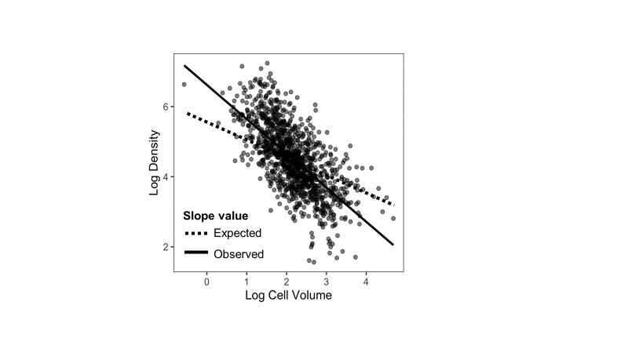

Fig. 3. The relationship between total population density and mean individual cell size (volume *μ*m3) of each phytoplankton community in 1048 lakes of the continental United States of America.



Fig. 4. Temperature (T), resource availability (P; total phosphorous), and zooplankton predation (P) interact to alter size-abundance relationships across 1048 lake phytoplankton communities. This figure is a visualization of a multiple regression model predicting total log10 population density (cells per mL) with mean log10 cell volume (*μ*m3), temperature (°C) and log10 nitrate concentration (mg per L), as well as interactions between those predictors. See methods for details of the fitted model. Although all predictors are treated as continuous in the model, we ‘slice’ the regression surface at 3 temperatures (10°, 20°, 30°C), 2 total phosphorous concentrations (3 mg L-1 and 300 mg L-1), and 2 zooplankton biomass levels (50 μg L-1 and 5000 μg L-1) to visualize changes in slope driven by these predictors. See Fig. 5 and 6 for different visualization of the same model.



Fig. 5.Temperature (T), total phosphorous (P), and zooplankton predation (Z) interact to alter size-abundance relationships across 1048 lake phytoplankton communities. This figure is another visualization (see Fig. 4 and 6) of a multiple regression model predicting total log10 population density (cells per mL) with mean log10 cell volume (μm3), temperature (°C) and log10 nitrate concentration (mg per L), as well as interactions between those predictors. See methods for details of the fitted model. Although all predictors are treated as continuous in the model, we ‘slice’ the regression surface at 3 total phosphorous concentrations (3 mg L-1, 30 mg L-1 and 300 mg L-1), 2 temperatures (10°, and 30°C), and 2 zooplankton biomass levels (50 μg L-1, 500 μg L-1 and 5000 μg L-1) to visualize changes in slope driven by these predictors. See Fig. 4 and 6 for different visualization of the same model.



Fig. 6 Temperature (T), total phosphorus (P), and zooplankton predation (Z) interact to alter size-abundance relationships across 1048 lake phytoplankton communities. This figure is another visualization (See Fig. 4 and 5) of a multiple regression model predicting total log10 population density (cells per mL) with mean log10 cell volume (µm3), temperature (°C) and log10 nitrate concentration (mg per L), as well as interactions between those predictors. See methods for details of the fitted model. Although all predictors are treated as continuous in the model, we ‘slice’ the regression surface at 3 zooplankton biomass levels (50 µg L-1, 500 µg L-1 and 5000 µg L-1), 2 total phospohorus concentrations (3 mg L-1, and 300 mg L-1), 2 temperatures (10°, and 30° C) to visualize changes in slope driven by these predictors. See Fig 4 and 5 for different viusalization of the same model.

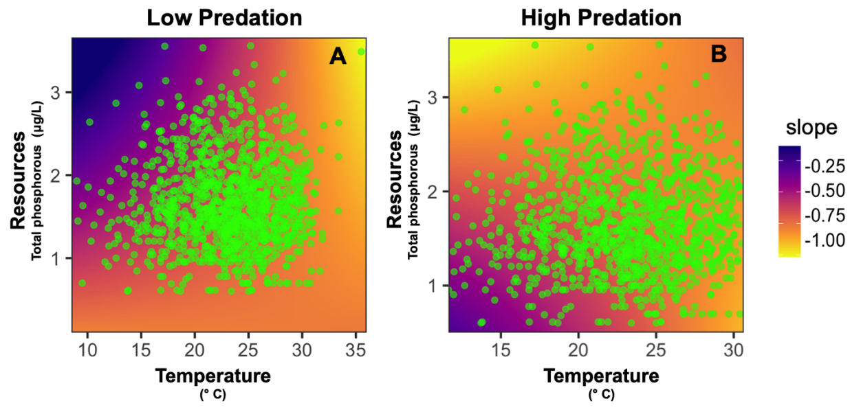

Fig. 7. An alternate visualization of the multiple regression results presented in Fig. 4, 5 and 6. The color variation indicates the slope of the size-abundance relationship across: temperature (° C) and resources (log transformed phosphorous gradients - mg L-1) under A. low and B. high predation predation (log transformed zooplankton biomass - μg L-1) pressure, estimated from the fitted regression. The green points represent individual lakes and indicate the temperature and phoshorous conditions at all 1048 lakes in the dataset (note that the lowest phosphrous values represent measurements below the detection limit; see methods for more detail). Note that this entire range of values is not observed in nature.

**Appendix**

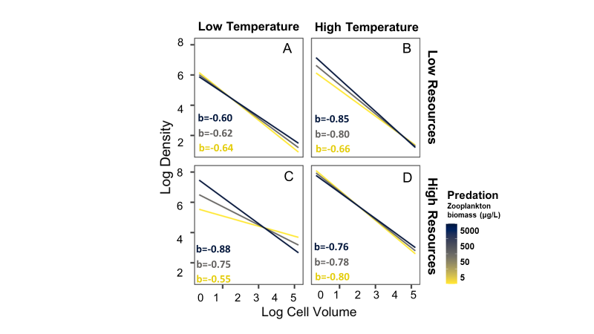

Fig. S1**.** Temperature (T), total phosphorous (P), and zooplankton predation (Z) interact to alter size-abundance relationships across 1048 lake phytoplankton communities. The fitted model is based on colony level size and density, rather than cell size and density, as shown in Fig. 6. This figure is a multiple regression model predicting total log10 population density (cells per mL) with mean log10 colony volume (μm3), temperature (°C) and log10 nitrate concentration (mg per L), as well as interactions between those predicted. Although all predictors are treated as continuous in the model, we ‘slice’ the regression surface at 3 zooplankton biomass levels (50 μg L-1, 500 μg L-1 and 5000 μg L-1), 2 total phosphorous concentrations (3 mg L-1, and 300 mg L-1), 2 temperatures (10°, and 30°C) to visualize changes in slope driven by these predictors. See Fig. 4 and 5 for different visualization of the same model.

**Supplementary Information**

*Tools used*

We used the following packages in R (v. 4.1.2) to visualise output from the fitted models: *interactions* (Long, 2019)*, modelsummary* (Arel-Bundock, 2022)*, sjPlot* (Lüdecke, 2022), *sjmisc* (Lüdecke, 2018a), *ggplot2* (Wickham, 2016)*, dplyr* (Wickham et al., 2022)*, ggeffects* (Lüdecke, 2018b)*, ggthemes* (Jeffrey, 2021)and *janitor* ( Firke, 2021)..

***Prior Choice***

We set the prior for the main slope of biovolume and density to *Normal*(-0.875, 2), which corresponds to the midpoint between -0.75 and -1, two commonly reported slope values. For the intercept, we set a prior of *Normal*(4, 1), which assumes mean phytoplankton densities ranging from ~100 to 1,000,000 cells per ml (i.e., 10^(4-2) to 10^(4+2)), consistent with previous studies in NLA lakes (Leech, Pollard, Labou, & Hampton, 2018). All other priors were centered at zero with *Normal*(0, 1), except for sigma, which was assigned *Exponential*(1). While these priors were informative based on previous work, they had little effect on the outcomes as confirmed by a prior sensitivity analysis (Figure S1).

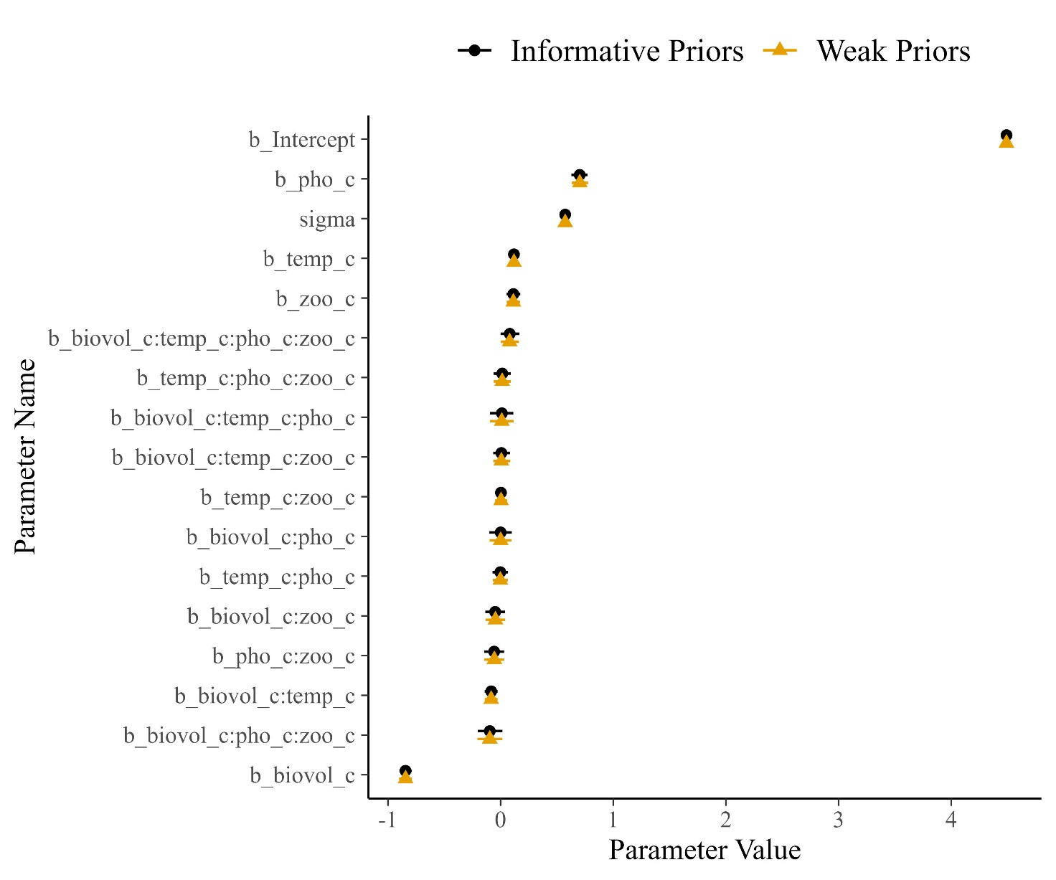

Figure S1. Prior sensitivity check showing model parameters estimated with informative priors (as described in the text) versus parameters estimated with weak priors (by doubling the standard deviations in the prior). Similarity of the points indicates that the inference comes almost entirely from the data, not the priors.

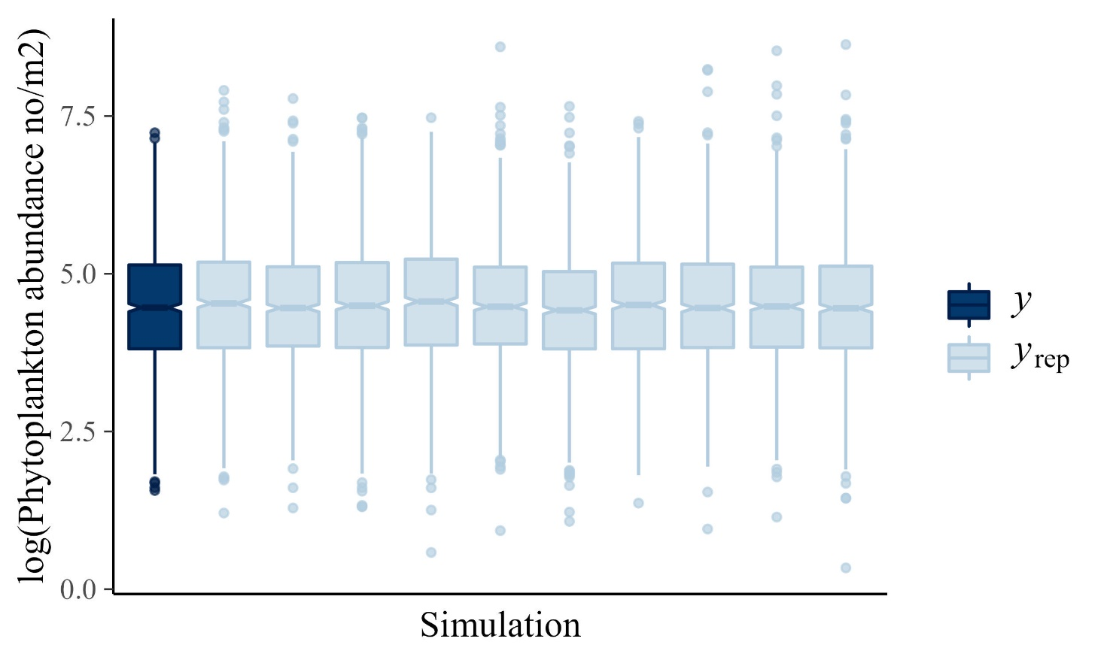

Figure S2. Posterior predictive check comparing the raw data (*y*) to 10 simulated datasets from the posterior distributions (*y*rep). Similarity in the boxplots indicates that the model generates data that are similar to the original data set, which indicates good model fit (Gabry et al. 2017).

**Suppelementary References**

Gabry, J., Simpson, D., Vehtari, A., Betancourt, M., & Gelman, A. (2017). Visualization in Bayesian workflow. *arXiv preprint arXiv:1709.01449*.

Jeffrey B. A. (2021). Ggthemes: Extra Themes, Scales and Geoms for ‘ggplot2’. R package version 4.2.4. <https://CRAN.R-project.org/package=ggthemes>

Long, J. A (2022). Interactions: Comprehensive, User-Friendly Toolkit for Probing Interactions. R package version 1.1.6, <https://cran.r-project.org/package=interactions>.

Lüdecke D (2022). sjPlot: Data Visualization for Statistics in Social Science. R package version 2.8.11, [https://CRAN.R-project.org/package=sjPlot](https://cran.r-project.org/package=sjPlot).

Lüdecke, D. (2018a). sjmisc: Data and variable transformation functions. *Journal of Open Source Software*, 3, 754.

Lüdecke, D. (2018b). ggeffects: Tidy data frames of marginal effects from regression models. *Journal of Open Source Software*, 3, 772.

Wickham, H. (2016). ggplot2: Elegant Graphics for Data Analysis. New York: Springer-Verlag.

Wickham, H., François, R., Henry, L., & Müller, K. (2022). dplyr: A Grammar of Data Manipulation. <https://dplyr.tidyverse.org>.